CHIMIMPORT AD
Interim Financial Statements
30 September 2008

Contents

 | Page
Interim Balance Sheet | 2
Interim Income Statement | 4
Interim Statement of Cash Flows (direct method) | 5
Interim Statement of Changes in Equity | 6
Notes to the Interim Financial Statements | 8

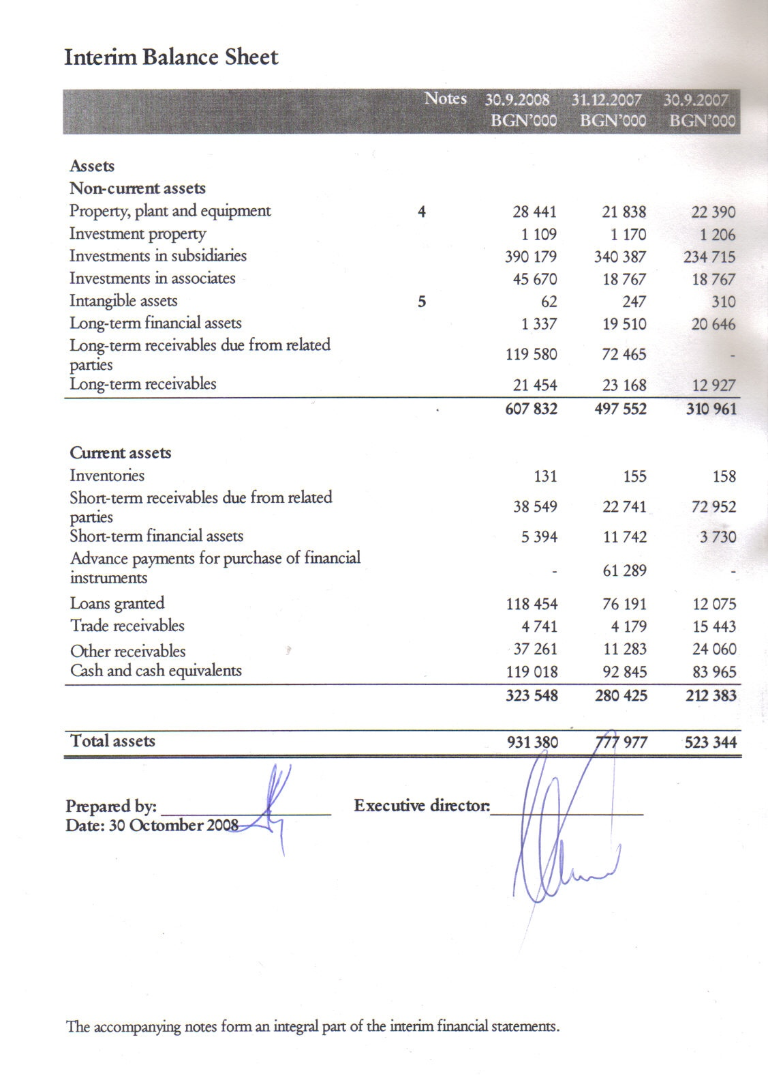
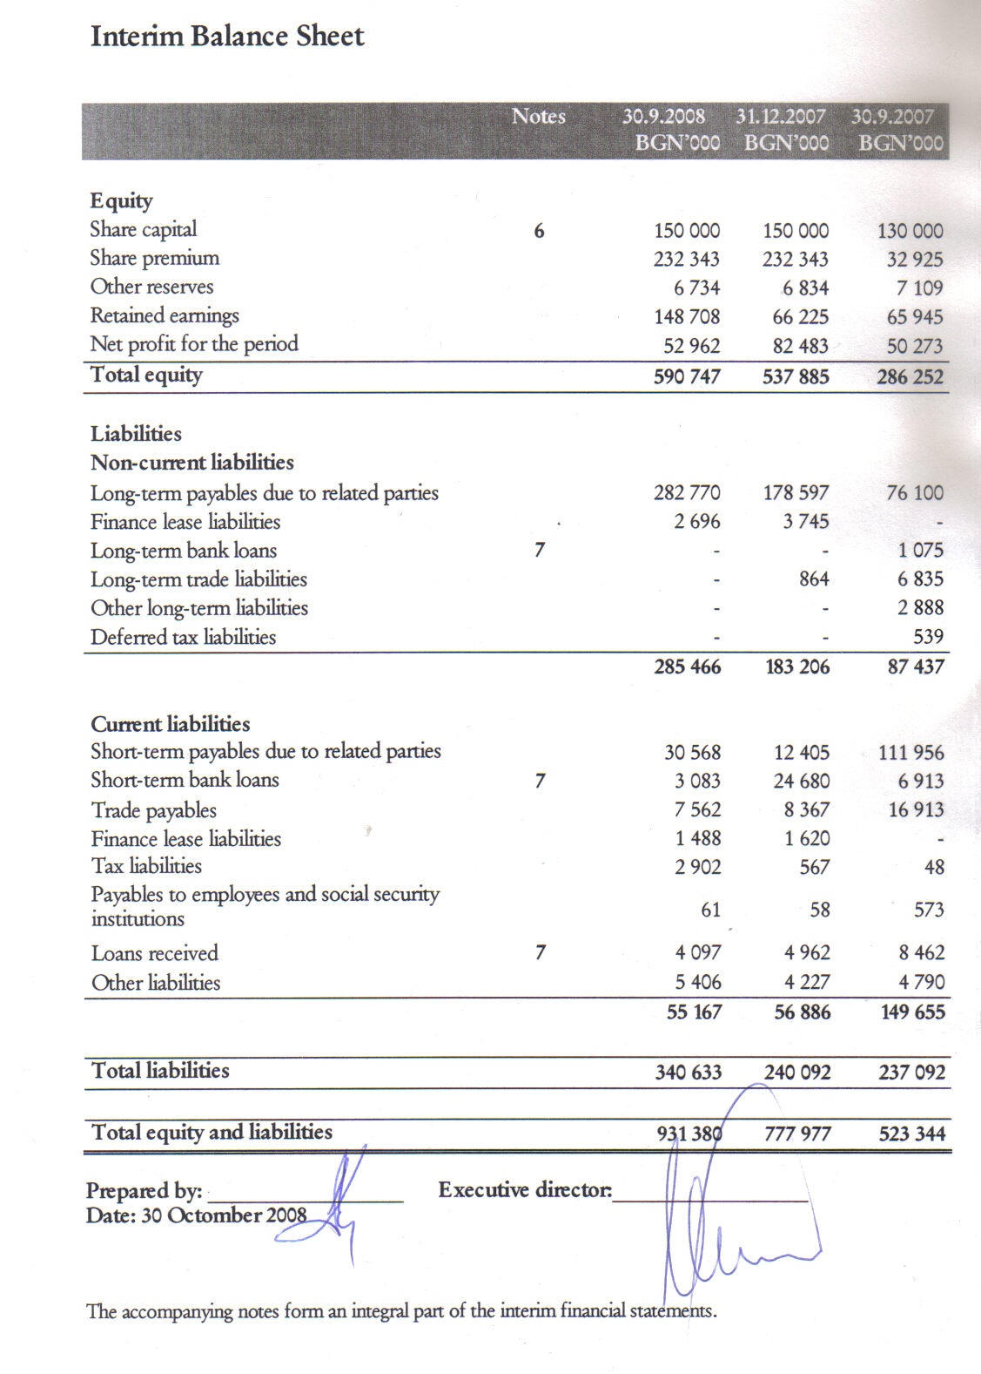
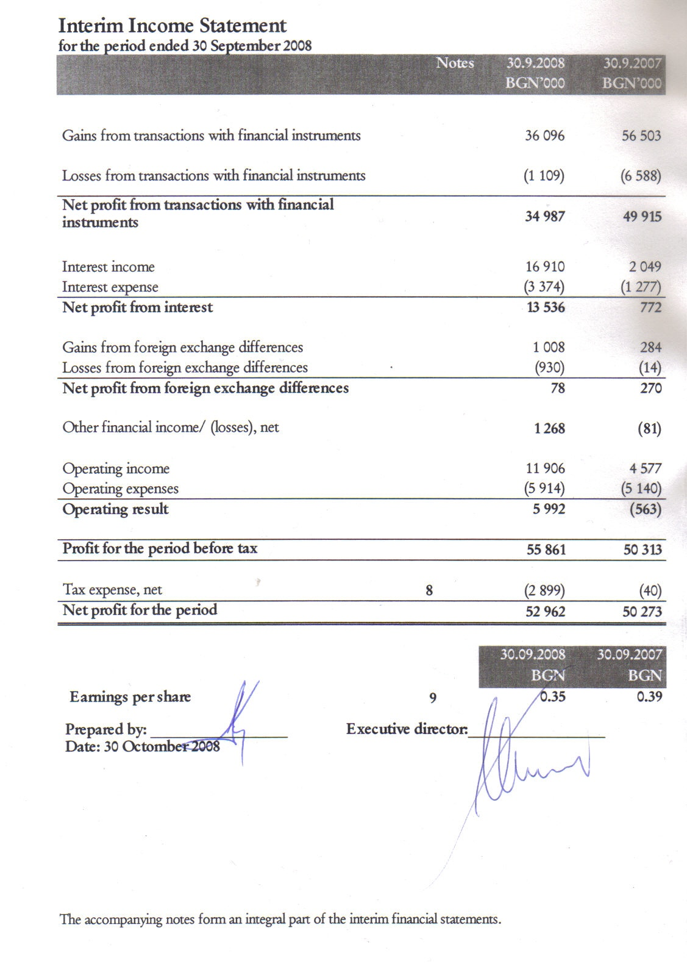

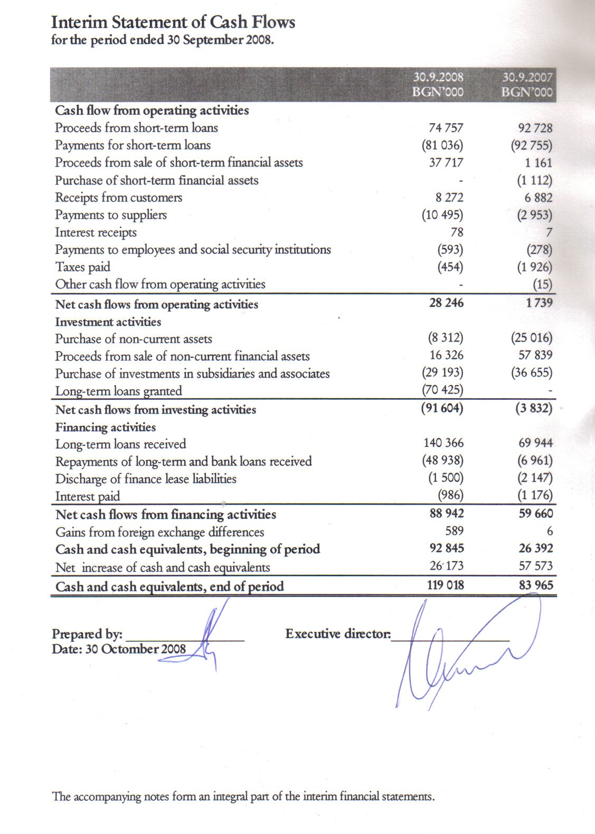
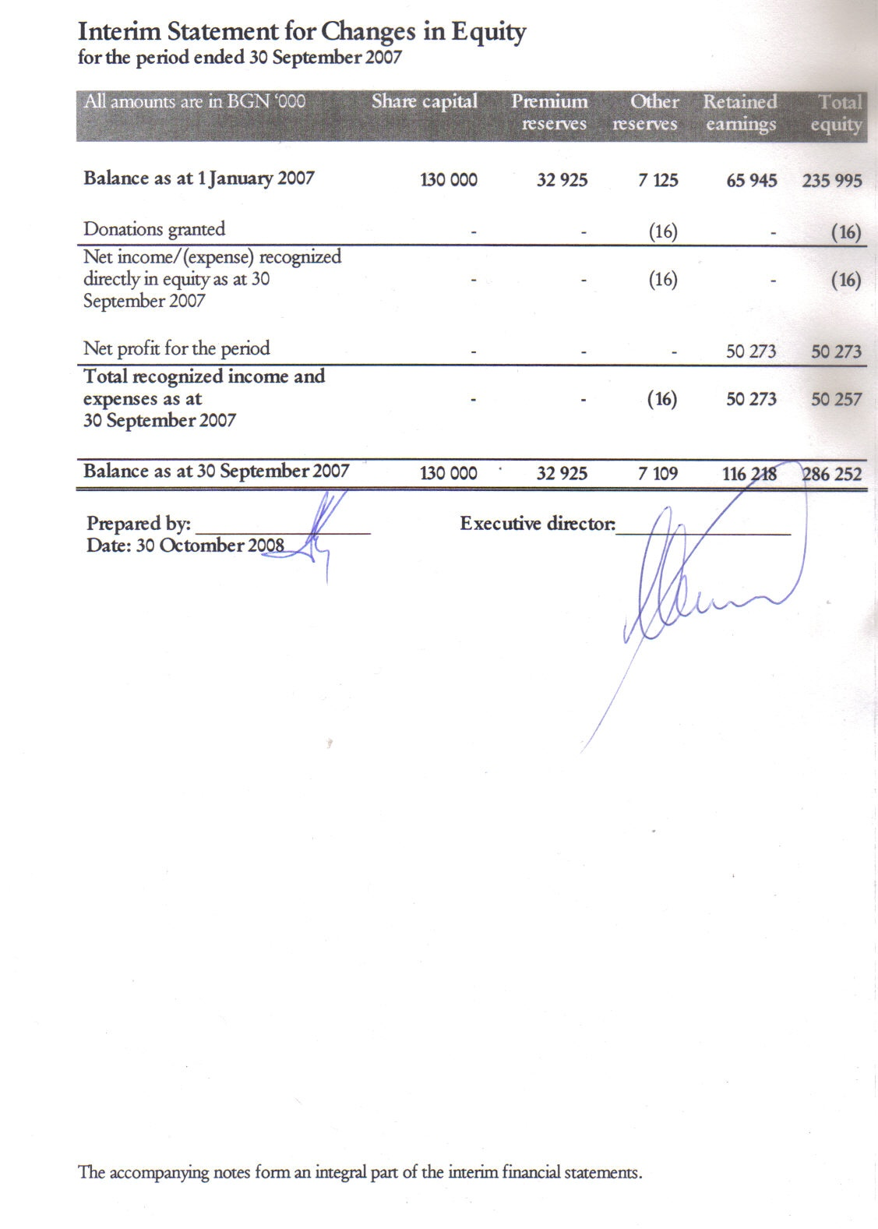

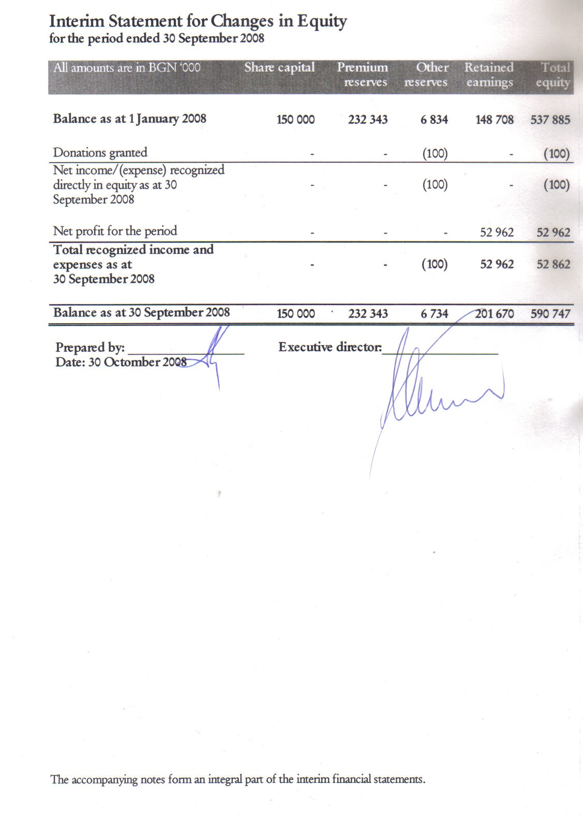
Notes to the Interim Financial Statements

General Information

CHIMIMPORT AD was registered as a joint-stock company at Sofia city court on 24 January 1990.

The main activity of the Company includes as follows:
- Acquisition, management and sale of shares in Bulgarian and foreign companies;
- Financing of companies in which interest is held;
- Banking services, finance, insurance and life insurance, pension and health insurance;
- Securitization of real estate and receivables;
- Extraction of crude oil and natural gas;
- Construction of output capacity in the area of oil-processing industry, production of biological fuel and production of rubber items;
- Production and trading with oil and chemical products;
- Production of vegetable oil, buyout, processing and trading with grain foods;
- Aviation transport and ground activities on servicing and repairing of aircrafts and aircraft engines;
- River and sea transport and harbor infrastructure;
- Trade representation and agency;
- Commission, forwarding and warehouse activity;

The interim financial statements as at 30 September 2008 is approved and accepted by the Managing Board on 30 Octomber 2008.

Basis for preparation of the consolidated financial statements

This condensed interim financial statements have been prepared in accordance with International Financial Reporting Standards (IFRS) as adopted by the EU, applicable to interim financial statements (IAS 34 Interim financial statements). The interim financial statements do not contain all information, as required for the preparation of complete annual financial statements and should be read in conjunction with the annual financial statements of the Company for the year ended 31 December 2007.

Company’s interim financial statements are presented in Bulgarian Leva (BGN), which is also the functional currency of the Company.

Accounting policies and changes during the period

Except as described below, the accounting policies applied are consistent with those of the annual financial statements for the year ended 31 December 2007, as described in those annual financial statements.

Taxes on income in the interim periods are accrued using the tax rate that would be applicable to expected total annual earnings.

The following new amendments to standards are mandatory for the first time from the 01 July 2008.

- Amendments in IAS 39 Financial instruments: recognition and measurement and IFRS 7 Financial instruments: disclosures, issued in October The deterioration of the world’s financial markets that has occurred during the third quarter of this year is a possible example of rare circumstances cited in these IFRS amendments and therefore justifies their immediate publication. Today’s action enables companies reporting according to IFRSs to use the reclassification amendments, if they so wish, from 1 July 2008.

The following new standards, amendments to standards or interpretations are mandatory for the first time for the financial year beginning 1 January 2008 but are not currently relevant for the Company:
- IFRIC 11 “IFRS 2 – Group and treasury share transactions”.
- IFRIC 12 “Service concession arrangements”.
- IFRIC 14 “IAS 19 – the limit on a defined benefit asset, minimum funding
requirements and their interaction”.

The following new standards, amendments to standards and interpretations have been issued but are not effective for the financial year beginning 1 January 2008 and have not been early adopted:

- IFRS 8 “Operating segments”, effective for annual periods beginning on or after 1 January 2009. IFRS 8 replaces IAS 14, “Segment reporting” and requires a “management approach” under which segment information is presented on the same basis as that used for internal reporting purposes. The expected impact is still being assessed by Company’s management.
- IAS 23 (amendment) “Borrowing costs”, effective for annual periods beginning on or after 1 January 2009. This amendment is not relevant to the Company, as the borrowing costs do not fulfill the criteria for recognizing interest expenses as a component of the cost of property, plant and equipment assets developed by the Company.
- IFRS 2 (amendment) “Share-based payment”, effective for annual periods beginning on or after 1 January 2009. The Company’s management does not foresee providing remuneration in the form of compensations with shares or shares purchase options.
- IFRS 3 (amendment) “Business combinations” and consequential amendments to IAS 27 “Consolidated and separate financial statements”, IAS 28 “Investments in associates” and IAS 31 “Interests in joint ventures”, effective prospectively to business combinations for which the acquisition date is on or after the beginning of the first annual reporting period beginning on or after 1 July 2009. Management is assessing the impact of the new requirements regarding acquisition accounting, consolidation and associates on the Company. The Company has associates.
- IAS 1 (amendment) “Presentation of financial statements”, effective for annual periods beginning on or after 1 January 2009. Management is in the process of developing proforma accounts under the revised disclosure requirements of this standard.
- IAS 32 (amendment) “Financial instruments: presentation” and consequential amendments to IAS 1 “Presentation of financial statements”, effective for annual periods beginning on or after 1 January 2009. This is not relevant to the Company, as the Company does not have any puttable instruments.
- IFRIC 13 “Customer loyalty programmes”, effective for annual periods beginning on or after 1 July 2008. Management does not apply customer loyalty programmes.
- IFRIC 15 “Agreements for the construction of real estate”, effective for annual periods beginning on or after 1 January 2009. The Company has not signed and does not intend to sign real estate construction agreements.
- IFRIC 16 “Hedges of a net investment in a foreign operation”, effective for annual periods beginning on or after 1 October 2008. The Company does not apply hedging of investments in foreign operations.

Property, plant and equipment

 | Land | Buildings | Machinery | Aircraft | Vehicles | Other | Assets in process of acquisition | Total
 | BGN’000 | BGN’000 | BGN’000 | BGN’000 | BGN’000 | BGN’000 | BGN’000 | BGN’000
Gross carrying amount | 401 | 654 | 1 057 | 22 042 | 179 | 607 | 4 023 | 28 963
Accumulated depreciation | - | (158) | (1 016) | (4 744) | (179) | (476) | - | (6 573)
Carrying amount 30 September 2007 | 401 | 496 | 41 | 17 298 | - | 131 | 4 023 | 22 390
Gross carrying amount | 401 | 654 | 1 057 | 22 042 | 179 | 607 | 4 023 | 28 963
Accumulated depreciation | - | (148) | (1 021) | (5 295) | (179) | (482) | - | (7 125)
Carrying amount 1 January 2008 | 401 | 506 | 36 | 16 747 | - | 125 | 4 023 | 21 838
Gross carrying amount | 8 581 | 654 | 1 069 | 22 042 | 179 | 695 | 4 052 | 37 272
Accumulated depreciation | - | (166) | (1 038) | (6 948) | (179) | (500) | - | (8 831)
Carrying amount 30 September 2008 | 8 581 | 488 | 31 | 15 094 | - | 195 | 4 052 | 28 441
The carrying amounts of the property, plant, and equipment presented in the interim financial statements as at 30 September 2008 are calculated as follows:

 | Land | Buildings | Machinery | Aircraft | Vehicles | Other | Assets in process of acquisition | Total
 | BGN’000 | BGN’000 | BGN’000 | BGN’000 | BGN’000 | BGN’000 | BGN’000 | BGN’000
Carrying amount as at 1 January 2007 | 401 | 528 | 45 | 18 951 | - | 149 | - | 20 074
Additions
- separately acquired | - | - | 10 | - | - | - | 4 023 | 4 033
Depreciation | - | (32) | (14) | (1 653) | - | (18) | - | (1 717)
Carrying amount as at  30 September 2007 | 401 | 496 | 41 | 17 298 | - | 131 | 4 023 | 22 390
Carrying amount as at 1 January 2008 | 401 | 506 | 36 | 16 747 | - | 125 | 4 023 | 21 838
Additions
- separately acquired | 8 180 | - | 12 | - | - | 88 | 107 | 8 387
Disposals – cost | - | - | - | - | - | - | (78) | (78)
Depreciation | - | (18) | (17) | (1 653) | - | (18) | - | (1 706)
Carrying amount as at  30 September 2008 | 8 581 | 488 | 31 | 15 094 | - | 195 | 4 052 | 28 441

Intangible assets

Intangible assets of the Company include acquired software licenses and software. Their carrying amount for the current accounting period can be presented as follows:

 | Property rights | Trade marks | Software licenses | Total
 | BGN’000 | BGN’000 | BGN’000 | BGN’000
Gross carrying amount | 981 | 1 | 48 | 1 030
Accumulated depreciation | (675) | - | (45) | (720)
Carrying amount 30 September 2007 | 306 | 1 | 3 | 310
 | 978 | 1 | 51 | 1 030
Gross carrying amount | (733) | (1) | (49) | (783)
Accumulated depreciation | 245 | - | 2 | 247
Carrying amount 1 January 2008
 | 978 | 1 | 51 | 1 030
 | (917) | (1) | (50) | (968)
Gross carrying amount | 61 | - | 1 | 62

The carrying amounts of the intangible assets, presented in the interim financial statements as at 30 September 2008 are calculated as follows:
 | Лицензи и патенти | Търговски марки | Софтуер | Общо
 | ‘000 лв | ‘000 лв | ‘000 лв | ‘000 лв
Carrying amount as at 1 January 2007 | 490 | 1 | 4 | 495
Additions
– separately acquired | - | - | 2 | 2
Amortization | (184) | - | (3) | (187)
Carrying amount as at  30 September 2007 | 306 | 1 | 3 | 310
Carrying amount as at 1 January 2008 | 245 | - | 2 | 247
Amortization | (184) | - | (1) | (185)
Carrying amount as at  30 September 2008 | 61 | - | 1 | 62

Share capital

The share capital of the Company consists only of 149 999 984 ordinary shares with a par value of BGN 1.00. All shares are equally eligible to receive dividends and the repayment of capital and represent one vote at the shareholders' meeting of the Company.

 | 30 September | 31 December
 | 2008 | 2007
 | BGN ‘000 | BGN‘000
Shares issued and fully paid:
- beginning of the year | 149 999 984 | 130 000 000
- issued during the year | - | 19 999 984
Shares issued and fully paid as at  30 September | 149 999 984 | 149 999 984

The list of the principal shareholders is as follows:

 | 30 September | 30 September | 31 December | 31 December
 | 2008 | 2008 | 2007 | 2007
 | Number of shares | % | Number of shares | %
Chimimport Invest AD | 114 616 084 | 76.41% | 114 808 367 | 76.54%
Julias Bear Investment management LLS – USA | 11 621 202 | 7.75% | 11 278 610 | 7.52%
Other legal entities and individuals | 23 762 698 | 15.84% | 23 913 007 | 15.94%
 |  | 100.00% |  | 100.00%

Loans

 | 30 September | 31 December | 30 September
 | 2008 | 2007 | 2007
 | BGN ‘000 | BGN ‘000 | BGN ‘000
Long-term bank loans | - | - | 1 075
Short-term bank and other loans | 7 180 | 29 642 | 15 375
 | 7 180 | 29 642 | 16 450
Changes in loans during the period are presented as follows:

 | ‘000 лв
For the period ended 30 September 2007
Opening balance 1 January 2007 | 12 062
Received during the period | 9 606
Repaid during the period | (5 218)
Closing balance 30 September 2007 | 16 450
For the period ended 30 September 2008
Opening balance 1 January 2008 | 29 642
Received during the period | -
Repaid during the period | (22 462)
Closing balance 30 September 2008 | 7 180

The Company has not received any new loans during the period, ended 30 September 2008.

Tax expenses

Recognized tax expenses are based on management’s best estimate of the expected annual tax rate. The tax rate, valid for 2008 is 10% corporate tax.

Earnings per share

The basic earnings per share have been calculated using the net results attributable to shareholders of the Company as the numerator.

The weighted average number of outstanding shares used for basic earnings per share as well as profits attributable to shareholders is as follows:

 | 30 September | 30 September
 | 2008 | 2007
 | BGN ‘000 | BGN ‘000
Net profit attributable to equity holders of the Company | 52 962 000 | 50 273 000
Weighted average number of ordinary shares in issue | 149 999 984 | 130 000 000
Basic earnings per share (BGN per share) | 0.3531 | 0.3867

Related parties transactions

Unless otherwise stated, none of the transactions incorporate special terms and conditions and no guarantee was given or received. Outstanding balances are usually settled in bank transfer.

Transactions with subsidiaries and associates
 | 30 September 2008 | 31 December 2007
 | BGN ‘000 | BGN ‘000
Sales
- Revenues from sales of goods
Chimimport Rubber OOD | 9 | 48
Chimimport Oil Trade OOD | - | 3
 | 9 | 51
- Revenues from transactions with financial instruments
Bulgarian Shipping Company EOOD | - | 4 850
ZPAD Armeec | - | 3 602
 | - | 8 452
- Revenues from services and rent
Hemus Air EAD | 3 287 | 4 893
Chimsnab AD | 2 610 | -
Brand New Ideas EOOD | 293 | 1 683
CCB AD | 239 | 505
AH Chimimport Consult OOD | 23 | 32
POAD CCB Sila | 70 | 97
Chimimport Fertilizers OOD | 47 | 16
Chimimport Rubber OOD | 11 | 17
PDNG AD | 10 | 13
Chimimport Orgachim OOD | 10 | 12
Chimtrans OOD | 8 | 10
Chimimport Lega Consult OOD | 2 | 5
Chimimport Oil Trade OOD | 9 | 10
Parahodstvo BRP AD | 4 | 4
Chimimport Chimtseltex OOD | 7 | 4
Bulgarian Shipping Company EAD | - | 135
Chimimport Finance AD | 4 | 1
 | 6 634 | 7 437
Purchase of services
- purchase of services
AH Chimimport Consult OOD | 162 | 239
Trans Interkar EOOD | 288 | 158
Chimimport Lega Consult OOD | 50 | 74
ZPAD Armeec | 18 | -
Brand New Ideas EOOD | 13 | 84
Chimimport Systems OOD | 6 | 19
Chimsnab AD | 9 | 16
Chimimport Orgachim OOD | - | 16
Chimimport Rubber OOD | 1 | 6
 | 547 | 612

Transactions with key management personnel
Key management personnel remuneration includes the following expenses:

 | 30 September 2008 | 31 December 2007
 | BGN ‘000 | BGN ‘000
Short-term remuneration
- salaries | 142 | 144
- social security costs | 15 | 13
- company car allowance | 16 | 20

Post balance sheet events

Chimimport AD plans to increase its capital

Chimimport AD plans to increase its capital through issuance of up to 50 million new shares. The Management Board of the company, after approval by the Supervisory Board, is going to determine the issuing value and the exact number of the new shares to be offered as according to preliminary calculations the issue will amount to ca. BGN 200 million. The funds of the capital increase will be used for financing of the investments and activities of the group of Chimimport.
The subscription to the new shares and the trade in rights on the floor of BSE-Sofia will start till the end of year 2008, after the Prospectus is approved by the FSC and is made public.
The public offering will be announced in the State Gazette and in Pari newspaper.
The entire notification is available on http://www.x3news.com..

