CHIMIMPORT AD
Interim consolidated financial statements
30 June 2008

Contents

 | Page
Interim consolidated balance sheet | 2
Interim consolidated income statement | 5
Interim consolidated cash flow statement | 7
Interim consolidated statement of changes in equity | 8
Notes to the interim consolidated financial statements | 9

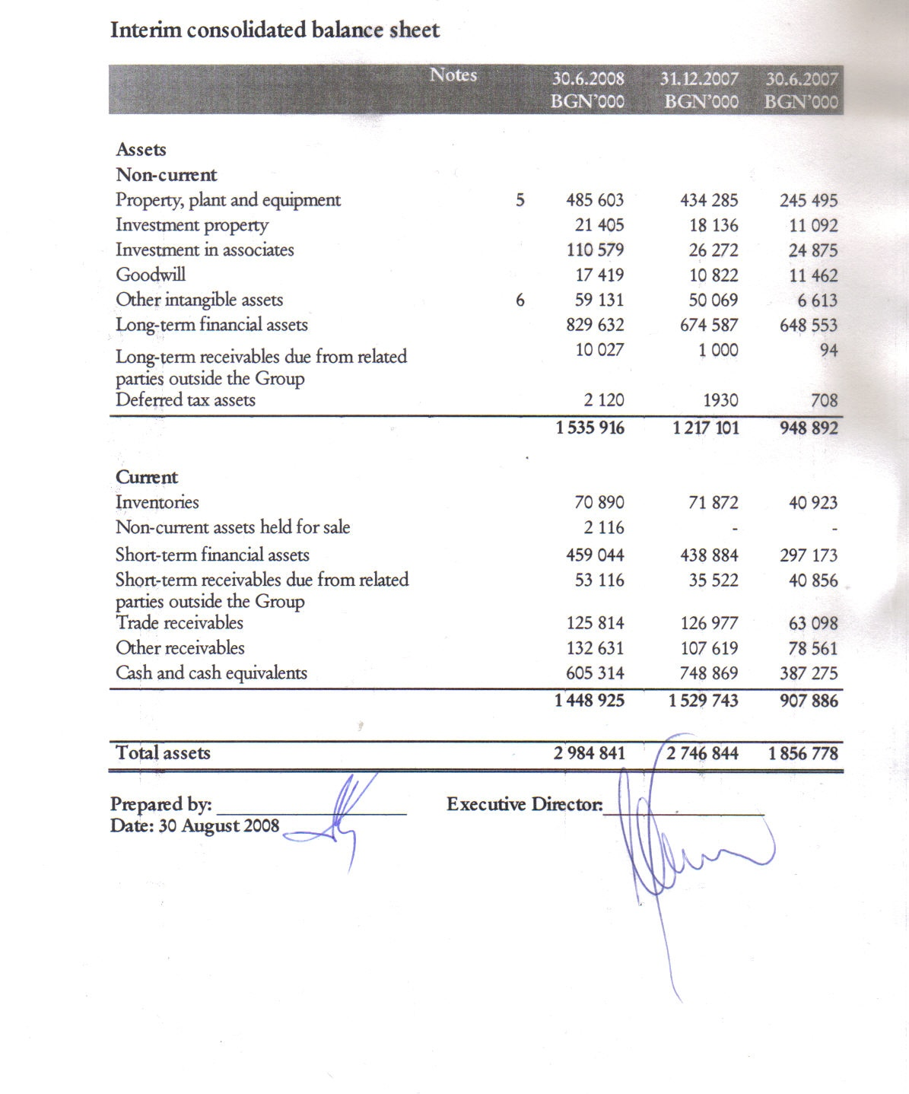

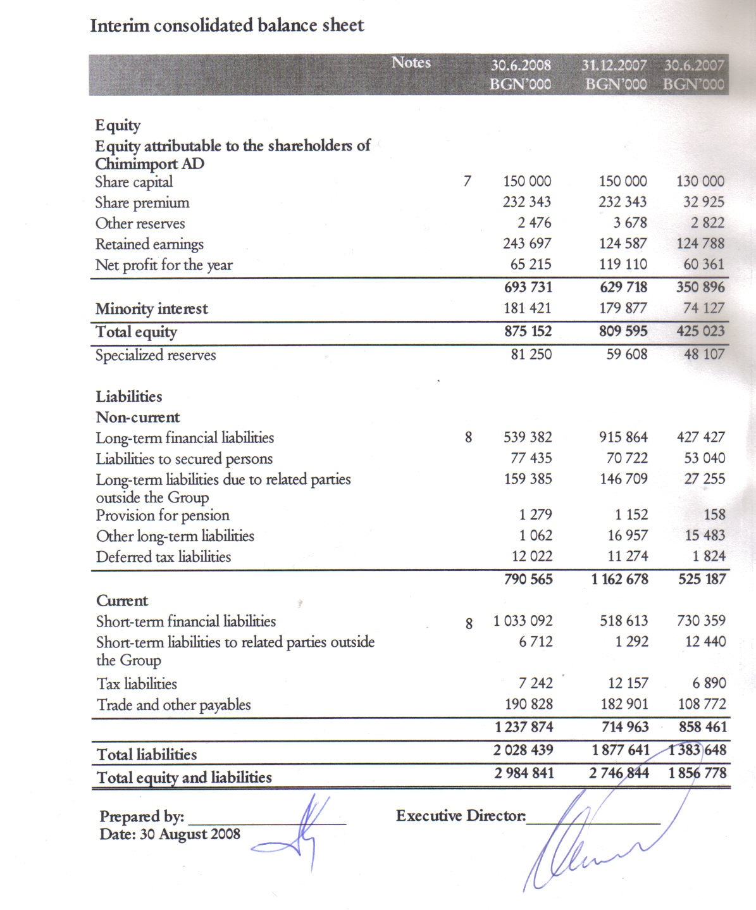
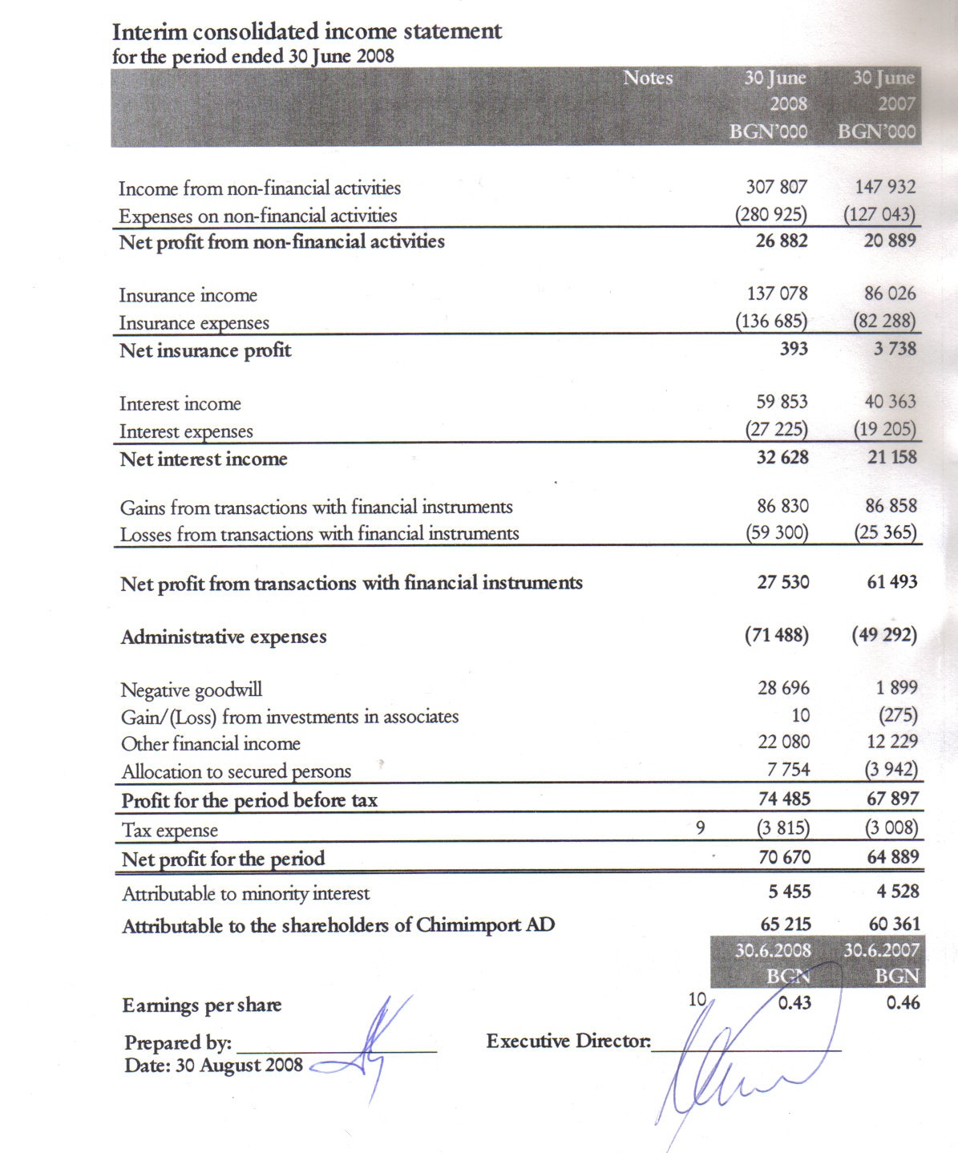
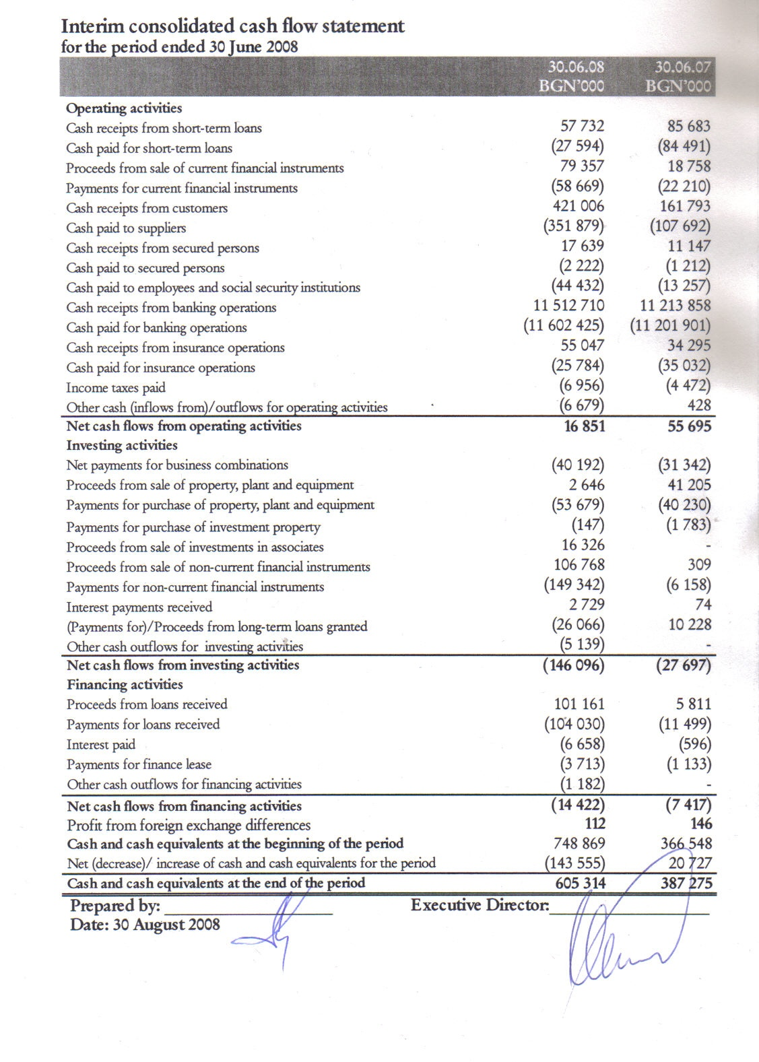
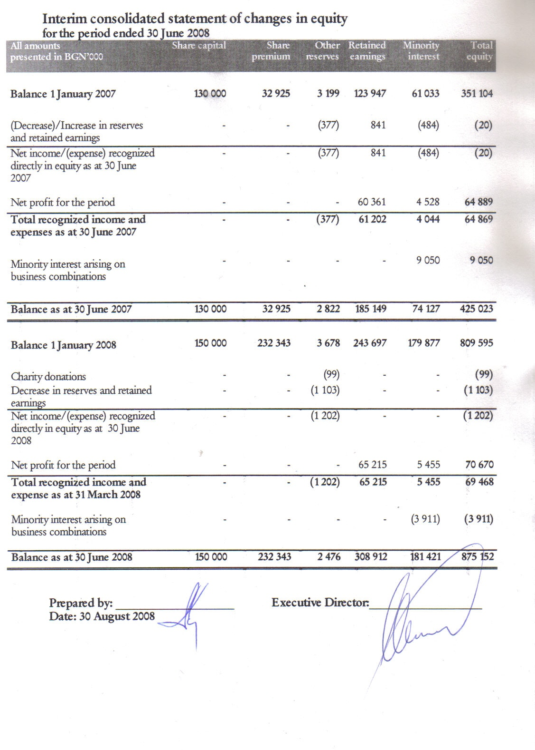
Notes to the Interim Consolidated Financial Statements

General Information

CHIMIMPORT AD was registered as a joint-stock company at Sofia city court on 24 January 1990.

The main activity of the Company includes as follows:
- Acquisition, management and sale of shares in Bulgarian and foreign companies;
- Financing of companies in which interest is held;
- Banking services, finance, insurance and life insurance, pension and health insurance;
- Securitization of real estate and receivables;
- Extraction of crude oil and natural gas;
- Construction of output capacity in the area of oil-processing industry, production of biological fuel and production of rubber items;
- Production and trading with oil and chemical products;
- Production of vegetable oil, buyout, processing and trading with grain foods;
- Aviation transport and ground activities on servicing and repairing of aircrafts and aircraft engines;
- River and sea transport and harbor infrastructure;
- Trade representation and agency;
- Commission, forwarding and warehouse activity;

The interim consolidated financial statements as at 30 June 2008 are approved and accepted by the Managing Board on 30 August 2008.

Basis for preparation of the consolidated financial statements

These condensed interim consolidated financial statements have been prepared in accordance with International Financial Reporting Standards (IFRS) as adopted by the EU, applicable to interim financial statements (IAS 34 Interim financial statements). The interim consolidated financial statements do not contain all information, as required for the preparation of complete annual financial statements and should be read in conjunction with the annual financial statements of the Group for the year ended 31 December 2007.

Group’s interim consolidated financial statements are presented in Bulgarian Leva (BGN), which is also the functional currency of the Group.

Accounting policies and changes during the period

Except as described below, the accounting policies applied are consistent with those of the annual financial statements for the year ended 31 December 2007, as described in those annual consolidated financial statements.

Taxes on income in the interim periods are accrued using the tax rate that would be applicable to expected total annual earnings.

The following new standards, amendments to standards or interpretations are mandatory for the first time for the financial year beginning 1 January 2008 and are currently relevant for the Group:
- IFRIC 12 “Service concession arrangements”.

The following new standards, amendments to standards or interpretations are mandatory for the first time for the financial year beginning 1 January 2008 but are not currently relevant for the Group:
- IFRIC 11 “IFRS 2 – Group and treasury share transactions”.
- IFRIC 14 “IAS 19 – the limit on a defined benefit asset, minimum funding requirements and their interaction”.

The following new standards, amendments to standards and interpretations have been issued but are not effective for the financial year beginning 1 January 2008 and have not been early adopted:

- IFRS 8 “Operating segments”, effective for annual periods beginning on or after 1 January 2009. IFRS 8 replaces IAS 14, “Segment reporting” and requires a “management approach” under which segment information is presented on the same basis as that used for internal reporting purposes. The expected impact is still being assessed by Group’s management.
- IAS 23 (amendment) “Borrowing costs”, effective for annual periods beginning on or after 1 January 2009. This amendment is not relevant to the Group, as the borrowing costs do not fulfill the criteria for recognizing interest expenses as a component of the cost of property, plant and equipment assets developed by the Group.
- IFRS 2 (amendment) “Share-based payment”, effective for annual periods beginning on or after 1 January 2009. The Company’s management does not foresee providing remuneration in the form of compensations with shares or shares purchase options.
- IFRS 3 (amendment) “Business combinations” and consequential amendments to IAS 27 “Consolidated and separate financial statements”, IAS 28 “Investments in associates” and IAS 31 “Interests in joint ventures”, effective prospectively to business combinations for which the acquisition date is on or after the beginning of the first annual reporting period beginning on or after 1 July 2009. Management is assessing the impact of the new requirements regarding acquisition accounting, consolidation and associates on the Group. The Group has associates.
- IAS 1 (amendment) “Presentation of financial statements”, effective for annual periods beginning on or after 1 January 2009. Management is in the process of developing proforma accounts under the revised disclosure requirements of this standard.
- IAS 32 (amendment) “Financial instruments: presentation” and consequential amendments to IAS 1 “Presentation of financial statements”, effective for annual periods beginning on or after 1 January 2009. This is not relevant to the Group, as the Group does not have any puttable instruments.
- IFRIC 13 “Customer loyalty programmes”, effective for annual periods beginning on or after 1 July 2008. Management does not apply customer loyalty programmes.
- IFRIC 15 “Agreements for the construction of real estate”, effective for annual periods beginning on or after 1 January 2009.
- IFRIC 16 “Hedges of a net investment in a foreign operation”, effective for annual periods beginning on or after 1 October 2008. The Group does not apply hedging of investments in foreign operations.

Segment reporting

For the reporting on segments the divisions of the Group are as follows:

- Production
- Financial Sector
- Transport Sector
- Real Estate
- Constructor and Engineering Sector

Business segments | Production | Financial Sector | Transport Sector | Real Estate | Construction and Engineering | Consolidation | Group
30.06.2008
 | BGN | BGN | BGN | BGN | BGN | BGN | BGN
 | ‘000s | ‘000s | ‘000s | ‘000s | ‘000s | ‘000s | ‘000s
Income from non-financial activities from external clients | 107 471 | 4 572 | 195 378 | 70 | 763 | (447) | 307 807
Inter-segment income | 31 690 | 2 253 | 14 150 | - | 70 | (48 163) | -
Total income from non-financial activities | 139 161 | 6 825 | 209 528 | 70 | 833 | (48 610) | 307 807
Net result from non-financial activities | 13 188 | 6 825 | 7 624 | (123) | (360) | (272) | 26 882
Insurance income from external clients | - | 137 078 | - | - | - | - | 137 078
Inter–segment insurance income | - | 5 877 | - | - | - | (5 877) | -
Total Insurance income | - | 142 955 | - | - | - | (5 877) | 137 078
Net profit from insurance | - | 5 916 | - | - | - | (5 523) | 393
Interest income | 1 463 | 63 311 | 654 | 63 | 23 | (5 661) | 59 853
Interest expense | (3 771) | (22 835) | (6 085) | (9) | (9) | 5 484 | (27 225)
Net interest income | (2 308) | 40 476 | (5 431) | 54 | 14 | (177) | 32 628
Gains from transactions with financial instruments from external clients | 802 | 86 448 | - | - | - | - | 87 250
Inter-segment gains from transactions with financial instruments | 10 | 8 467 | - | - | - | (8 897) | (420)
Total gains from transactions with financial instruments | 812 | 94 915 | - | - | - | (8 897) | 86 830
Net profit from transactions with financial instruments | 812 | 2 478 | - | - | - | 24 240 | 27 530
Administrative expenses | (4 412) | (60 292) | (9 090) |  |  | 2 306 | (71 488)
Negative goodwill | - | - | - | - | - | 28 696 | 28 696
Other financial income/(expense) | (543) | 24 366 | (1 408) | (16) | (1) | (318) | 22 080
Result from investments in equity accounted associates | (9) | 326 | (335) | 28 | - | - | 10
Allocation to secured persons | - | 7 754 | - | - | - | - | 7 754
Profit for the year before tax | 6 728 | 27 849 | (8 640) | (57) | (347) | 48 952 | 74 485
Tax expenses | (748) | (2 611) | (456) | - | - | - | (3 815)
Net result for the period | 5 980 | 25 238 | (9 096) | (57) | (347) | 48 952 | 70 670

Business segments | Production | Financial Sector | Transport Sector | Real Estate | Construction and Engineering | Consolidation | Group
30.06.2008
 | BGN | BGN | BGN | BGN | BGN | BGN | BGN
 | ‘000s | ‘000s | ‘000s | ‘000s | ‘000s | ‘000s | ‘000s
Assets of the segment | 528 096 | 2 889 128 | 457 070 | 46 261 | 8 874 | (1 055 167) | 2 874 262
Investments in equity accounted associates | 158 | 45 665 | 6 455 | 1 760 | - | 56 541 | 110 579
Consolidated total assets | 528 254 | 2 934 793 | 463 525 | 48 021 | 8 874 | (998 626) | 2 984 841
Specialized reserves | - | 81 250 | - | - | - | - | 81 250
Segment liabilities | 238 285 | 1 772 925 | 325 029 | 864 | 3 002 | (311 666) | 2 028 439
Consolidated total liabilities | 238 285 | 1 772 925 | 325 029 | 864 | 3 002 | (311 666) | 2 028 439

Business segments | Production | Financial Sector | Transport Sector | Real Estate | Construction and Engineering | Consolidation | Group
30.06.2007
 | BGN | BGN | BGN | BGN | BGN | BGN | BGN
 | ‘000s | ‘000s | ‘000s | ‘000s | ‘000s | ‘000s | ‘000s
Income from non-financial activities from external clients | 53 583 | 6 112 | 87 673 | 365 | 199 | - | 147 932
Inter-segment income | 2 885 | 2 991 | 1 030 |  | - | (6 906) | -
Total Income from non-financial activities | 56 468 | 9 103 | 88 703 | 365 | 199 | (6 906) | 147 932
Net result from non-financial activities | 4 580 | 9 103 | 7 819 | (103) | (140) | (370) | 20 889
Insurance income from external clients | - | 86 026 | - | - | - | - | 86 026
Inter – segment insurance income | - | 1 414 | - | - | - | (1 414) | -
Total Insurance income | - | 87 440 | - | - | - | (1 414) | 86 026
Net profit from insurance | - | 5 053 | - | - | - | (1 315) | 3 738
Interest income | 40 | 41 690 | 8 | - | - | (1 375) | 40 363
Interest expense | (1 326) | (16 922) | (2 229) | - | - | 1 272 | (19 205)
Net interest income | (1 286) | 24 768 | (2 221) | - | - | (103) | 21 158
Gains from transactions with financial instruments from external clients | 2 | 85 873 | 12 165 | - | - | (11 182) | 86 858
Inter-segment gains from transactions with financial instruments | - | 7 813 | - | - | - | (7 813) | -
Total gains from transactions with financial instruments | 2 | 93 686 | 12 165 | - | - | (18 995) | 86 858
Net profit from transactions with financial instruments | (8) | 61 754 | 12 165 | - | - | (12 418) | 61 493
Administrative expenses |  | (51 426) |  |  |  | 2 134 | (49 292)
Negative goodwill | - | - | - | - | - | 1 899 | 1 899
Other financial income/(expense) | 47 | 13 415 | (952) | - | - | (281) | 12 229
Result from investments in equity accounted associates | 23 | (298) | - | - | - | - | (275)
Allocation to secured persons | - | (3 942) | - | - | - | - | (3 942)
Profit for the year before tax | 3 356 | 58 427 | 16 811 | (103) | (140) | (10 454) | 67 897
Tax expenses | (688) | (1 784) | (536) | - | - | - | (3 008)
Net result for the period | 2 668 | 56 643 | 16 275 | (103) | (140) | (10 454) | 64 889

Business segments | Production | Financial Sector | Transport Sector | Real Estate | Construction and Engineering | Consolidation | Group
30.06.2007
 | BGN | BGN | BGN | BGN | BGN | BGN | BGN
 | ‘000s | ‘000s | ‘000s | ‘000s | ‘000s | ‘000s | ‘000s
Assets of the segment | 159 805 | 1 891 737 | 289 014 | 35 561 | 5 074 | (524 413) | 1 856 778
Investments in equity accounted associates | 158 | 17 671 | 500 | - | - | 6 546 | 24 875
Consolidated total assets | 159 963 | 1 909 408 | 289 514 | 35 561 | 5 074 | (517 867) | 1 881 653
Specialized reserves | - | 48 107 | - | - | - | - | 48 107
Segment liabilities | 87 730 | 1 258 473 | 164 536 | 77 | 2 036 | (129 204) | 1 383 648
Consolidated total liabilities | 87 730 | 1 258 473 | 164 536 | 77 | 2 036 | (129 204) | 1 383 648

Property, plant and equipment

 | Land | Buildings | Machines | Technical equipment | Transportation vehicles | Other | Assets in process of acquisition | Total
 | BGN’000 | BGN’000 | BGN’000 | BGN’000 | BGN’000 | BGN’000 | BGN’000 | BGN’000
Gross carrying amount | 33 001 | 61 868 | 42 196 | 53 513 | 88 592 | 27 005 | 31 085 | 337 260
Accumulated depreciation | - | (13 145) | (20 528) | (16 254) | (21 531) | (20 307) | - | (91 765)
Carrying amount 30 June 2007 | 33 001 | 48 723 | 21 668 | 37 259 | 67 061 | 6 698 | 31 085 | 245 495
Gross carrying amount | 87 638 | 122 164 | 64 784 | 80 649 | 85 572 | 25 180 | 67 695 | 533 682
Accumulated depreciation | - | (14 438) | (21 823) | (14 772) | (27 989) | (20 375) | - | (99 397)
Carrying amount 1 January 2008 | 87 638 | 107 726 | 42 961 | 65 877 | 57 583 | 4 805 | 67 695 | 434 285
Gross carrying amount | 98 290 | 136 506 | 58 982 | 90 596 | 107 249 | 27 993 | 79 666 | 599 282
Accumulated depreciation | - | (16 865) | (26 044) | (16 474) | (33 013) | (21 283) | - | (113 679)
Carrying amount 30 June 2008 | 98 290 | 119 641 | 32 938 | 74 122 | 74 236 | 6 710 | 79 666 | 485 603
The carrying amounts of the property, plant, and equipment presented in the interim consolidated financial statements as at 30 June 2008 are calculated as follows:

 | Land | Buildings | Machines | Technical equipment | Transportation vehicles | Other | Assets in process of acquisition | Total
 | BGN’000 | BGN’000 | BGN’000 | BGN’000 | BGN’000 | BGN’000 | BGN’000 | BGN’000
At 1 January 2007
Opening net book amount | 28 668 | 47 025 | 20 244 | 37 661 | 47 254 | 3 372 | 17 230 | 201 454
Business combinations - cost | 4 333 | 2 676 | 1 554 | 832 | 12 853 | 112 | 39 | 22 399
Business combinations – depreciation | - | (373) | (462) | (118) | (2 407) | (47) | - | (3 407)
Additions | - | 348 | 2 900 | 773 | 18 954 | 3 713 | 18 497 | 45 185
Disposals – cost | - | - | (58) | (495) | (8 162) | (223) | (4 681) | (13 619)
Disposals – depreciation | - | - | 59 | 473 | 866 | 6 | - | 1 404
Depreciation charge | - | (953) | (2 569) | (1 867) | (2 297) | (235) | - | (7 921)
Closing net book amount | 33 001 | 48 723 | 21 668 | 37 259 | 67 061 | 6 698 | 31 085 | 245 495
As at 30 June 2007
Cost | 33 001 | 61 868 | 42 196 | 53 513 | 88 592 | 27 005 | 31 085 | 337 260
Accumulated depreciation | - | (13 145) | (20 528) | (16 254) | (21 531) | (20 307) | - | (91 765)
Net book amount | 33 001 | 48 723 | 21 668 | 37 259 | 67 061 | 6 698 | 31 085 | 245 495

 | Land | Buildings | Machines | Technical equipment | Transportation vehicles | Other | Assets in process of acquisition | Total
 | BGN’000 | BGN’000 | BGN’000 | BGN’000 | BGN’000 | BGN’000 | BGN’000 | BGN’000
At 1 January 2008
Opening net book amount | 87 638 | 107 726 | 42 961 | 65 877 | 57 583 | 4 805 | 67 695 | 434 285
Business combinations - cost | 231 | 10 606 | 1 308 | 3 071 | 4 981 | 1 907 | 5 188 | 27 292
Business combinations – depreciation | - | (793) | (103) |  | (1 313) | (485) | - | (2 694)
Additions | 10 624 | 4 262 | 6 591 | 6 905 | 16 933 | 957 | 38 200 | 84 472
Reclassification | - | - | (11 503) | - | - | - | (22 338) | (33 841)
Disposals – cost | (203) | (526) | (2 198) | (29) | (237) | (51) | (9 079) | (12 323)
Disposals – depreciation | - | 30 | 233 | 23 | 142 | 40 | - | 468
Depreciation charge | - | (1 664) | (4 351) | (1 725) | (3 853) | (463) | - | (12 056)
Closing net book amount | 98 290 | 119 641 | 32 938 | 74 122 | 74 236 | 6 710 | 79 666 | 485 603
As at 30 June 2008
Cost | 98 290 | 136 506 | 58 982 | 90 596 | 107 249 | 27 993 | 79 666 | 599 282
Accumulated depreciation | - | (16 865) | (26 044) | (16 474) | (33 013) | (21 283) | - | (113 679)
Net book amount | 98 290 | 119 641 | 32 938 | 74 122 | 74 236 | 6 710 | 79 666 | 485 603

Intangible assets

Intangible assets of the Group include acquired software licenses and software. Their carrying amount for the current accounting period can be presented as follows:

 | Trade marks | Repairs of rented assets | Licenses and patents | Software products | Internally generated intangible assets | Total
 | BGN‘000 | BGN‘000 | BGN‘000 | BGN‘000 | BGN‘000 | BGN‘000
Gross carrying amount | 61 | 7 604 | 3624 | 1278 | 54 | 12 621
Accumulated amortization | (47) | (2672) | (2332) | (905) | (52) | (6 008)
Carrying amount 30 June 2007 | 14 | 4 932 | 1 292 | 373 | 2 | 6 613
Gross carrying amount | 52 | 23 014 | 3 613 | 32 136 | 989 | 59 804
Accumulated amortization | (52) | (3 333) | (2 438) | (3 235) | (677) | (9 735)
Carrying amount 01 January 2008 | - | 19 681 | 1 175 | 28 901 | 312 | 50 069
Gross carrying amount | 52 | 35 032 | 3 858 | 32 970 | 1 516 | 73 428
Accumulated amortization | (52) | (5 895) | (2 705) | (4 889) | (756) | (14 297)
Carrying amount 30 June 2008 | - | 29 137 | 1 153 | 28 081 | 760 | 59 131

The carrying amounts of the intangible assets, presented in the interim consolidated financial statements as at 30 June 2008 are calculated as follows:

 | Trade marks |  | Repairs of rented assets | Licenses and patents | Software products | Internally generated intangible assets | Total
 | BGN‘000 |  | BGN‘000 | BGN‘000 | BGN‘000 | BGN‘000 | BGN‘000
Carrying amount as at 1 January 2007 | 33 | 4 873 |  | 1 547 | 455 | 2 | 6 910
Additions | - | 685 |  | 28 | 31 | - | 744
Disposals – cost | - | (56) |  | - | - | - | (56)
Disposals – amortization | - | 2 |  | - | - | - | 2
Amortization charge | (19) | (572) |  | (283) | (113) | - | (987)
Carrying amount as at 30 June 2007 | 14 | 4 932 |  | 1 292 | 373 | 2 | 6 613
Carrying amount as at 1 January 2008 | - | 19 681 |  | 1 175 | 28 901 | 312 | 50 069
Business combinations - cost | - | 5 855 |  | 205 | 834 | - | 6 894
Business combinations – amortization | - | (98) |  | - | (39) | (1) | (138)
Additions | - | 6 191 |  | 40 | - | 528 | 6 759
Disposals – cost | - | (28) |  | - | - | (1) | (29)
Disposals – amortization | - | 1 |  | - | - | 1 | 2
Amortization charge | - | (2 465) |  | (267) | (1 615) | (79) | (4 426)
Carrying amount as at 30 June 2008 | - | 29 137 |  | 1 153 | 28 081 | 760 | 59 131

Share capital

The share capital of the Company consists only of 149 999 984 ordinary shares with a par value of BGN 1.00. All shares are equally eligible to receive dividends and the repayment of capital and represent one vote at the shareholders' meeting of the Company.

 | 30 June | 31 December
 | 2008 | 2007
 | BGN ‘000 | BGN‘000
Shares issued and fully paid:
- beginning of the year | 149 999 984 | 130 000 000
- issued during the year | - | 19 999 984
Shares issued and fully paid | 149 999 984 | 149 999 984

The list of the principal shareholders is as follows:

 | 30 June | 30 June | 31 December | 31 December
 | 2008 | 2008 | 2007 | 2007
 | Number of shares | % | Number of shares | %
Chimimport Invest AD | 114 616 084 | 76.41% | 114 808 367 | 76.54%
Julias Bear Investment management LLS – USA | 11 884 353 | 7.92% | 11 278 610 | 7.52%
Other legal entities and individuals | 23 499 547 | 15.67% | 23 913 007 | 15.94%
 |  | 100% |  | 100%

Loans

 | 30 June | 31 December | 30 June
 | 2008 | 2007 | 2007
 | BGN ‘000 | BGN ‘000 | BGN ‘000
Long-term loans | 1 033 092 | 915 864 | 427 427
Short-term loans | 539 382 | 518 613 | 730 359
 | 1 572 474 | 1 434 477 | 1 157 786
Changes in loans during the period are presented as follows:

 | BGN ‘000
For the period ended 30 June 2008
Opening balance 1 January 2008 | 1 434 477
Received during the period | 151 390
Repaid during the period | (13 393)
Closing balance 30 June 2008 | 1 572 474

Tax expenses

Recognized tax expenses are based on management’s best estimate of the expected annual tax rate. The tax rate, valid for 2008 is 10% corporate tax.

Earnings per share

The basic earnings per share is determined by dividing the net profit for the period attributable to the equity holders of Chimimport AD.

The weighted average number of outstanding shares used for basic earnings per share as well as profits attributable to shareholders is as follows:

 | 30 June | 30 June
 | 2008 | 2007
 | BGN | BGN
Net profit attributable to equity holders | 65 215 000 | 60 361 000
Weighted average number of ordinary shares in issue | 150 000 000 | 130 000 000
Basic earnings per share (BGN per share) | 0.4355 | 0.4643

Business combinations

Acquisition of 59.23 % of the share capital of Silex Bank AD – Macedonia

In 2008 59.23% of the share capital of Silex Bank AD were acquired. As a result of the acquisition, goodwill amounting to TBGN 6 597 has been recognized.

The acquired business contributed revenues of TBGN 1 339 and net profit of TBGN 561 to the Group for the period from acquisition to 30 June 2008.

Details of net assets acquired and goodwill are as follows:

 | 2008
 | BGN ‘000
Purchase consideration:
- Purchase price | 20 391
Fair value of net assets acquired (see below) | (13 794)
Goodwill | 6 597

The fair value of the net assets acquired is different from the book value of the net assets acquired. The fair value adjustments reflect the recognition of intangible assets identified during the initial recognition of the business combination.

The fair value of the acquired net assets is presented as follows:
 | Fair value | Book value of the company acquired
 | 2008 | 2008
 | BGN‘000 | BGN‘000
Cash and cash equivalents | 43 128 | 43 128
Property, plant and equipment | 9 282 | 10 291
Other intangible assets | 7 652 | 1 651
Investment Property | 4 006 | 2 993
Receivables | 351 | 351
Liabilities | (41 132) | (40 531)
Net assets | 23 287 | 17 883
Minority interest | (9 493)
Net assets acquired | 13 794

Related parties transactions

Unless otherwise stated, none of the transactions incorporate special terms and conditions and no guarantee was given or received. Outstanding balances are usually settled in cash.

Related parties transactions
Transactions with associates | 30 June | 30 June  2007
Transactions with associates | 2008 | 30 June  2007
 | BGN‘000 | BGN‘000
Sales
- Revenues from sales of production
Kavarna Gaz OOD | 733 | 491
- Revenues from services
Fraport TSEM AD | 150 | -
- Interest income
Holding Nov Vek AD | 353 | -
Holding Varna A AD | 62 | -
Fraport TSEM AD | 208 | -
 | 1 506 | 491

Transactions with shareholders | 30 June | 30 June  2007
Transactions with shareholders | 2008 | 30 June  2007
 | BGN‘000 | BGN‘000
- purchase of services
Chimimport Invest AD | (5) | (13)
 | (5) | (13)

Transactions with key management personnel

Key management personnel remuneration includes the following expenses:
 | 30 June | 30 June
 | 2008 | 2007
 | BGN‘000 | BGN‘000
Short-term remuneration
- salaries | 100 | 144
- social security costs | 11 | 13
- company car allowance | 7 | 20

Post balance sheet events

On 18 August 2008 Chimimport AD announced that, with the consent of its Supervisory Board, it has successfully priced and placed EUR 65 million seven-year secured bonds exchangeable for its ordinary shares listed on the Bulgarian Stock Exchange (the “Exchangeable Bonds” or the “Bonds”). At the option of Chimimport, the issue size can be further increased by up to EUR 15 million at the terms fixed at pricing (as described below).

The Bonds are issued by Chimimport’s wholly-owned finance subsidiary – Chimimport Holland B.V. (the “Issuer”) incorporated in the Netherlands. The Issuer will on-lend the proceeds of the Bonds to Chimimport which intends to use the net proceeds for financing expansion through strategic acquisitions and for general corporate purposes.

11.6 million existing ordinary shares of Chimimport held by its majority shareholder, Chimimport Invest AD (“Chimimport Invest”), will be secured for the benefit of the Bondholders pursuant to a share pledge and will be blocked from any dealings. Upon exchange, Chimimport Invest will have the option to deliver cash instead of the underlying shares to mitigate dilution.

Chimimport is the first Bulgarian corporate to offer equity-linked bonds outside Bulgaria. The Exchangeable Bonds provide Chimimport with access to the European capital markets and the expansion of its existing investor base. The transaction also aims to provide flexibility and diversity to Chimimport’s funding mix on terms preferential to those proposed by other financing alternatives.

The Bonds are issued at 100% and, unless previously exchanged, redeemed or repurchased and cancelled, will be redeemed on 22nd August 2015 at 118.9% of the principal amount thereof plus accrued interest.

The Bonds carry a fixed 7% annual coupon. The initial exchange price is fixed at BGN 10.984, representing a 30% premium to the reference price established over a 5-day VWAP prior to the pricing date. The Bondholders will have the right to request an early redemption at accreted principal amount plus accrued interest on the 2nd and 4th anniversary of the Bonds. Furthermore, the Issuer will be able to call the outstanding Bonds after 22nd August 2011 if Chimimport’s share price trades at or above 130% of the then prevailing exchange price. The Bonds will be offered for trade on August 22nd.

UniCredit Market & Investment Banking (acting through Bayerische Hypo- und Vereinsbank) is acting as Sole Bookrunner on the transaction.
Under a decision of Budapest City Court, Hungary dated 30.06.2008, has been registered a subsidiary of Chimimport AD, namely the trade company Chimimport Hungary Kereskedelmi Korlatolt Felelossegu Tarshoshag, in brief Chimimport Hungary Kft Limited, with a registered address: 1026 Budapest, 6/3 Gabor Aron St.
The company has the following scope of business activity: Inland water transportation of goods, wholesale trade on consignment; purchase and sale of real estates, giving them for rent, real estates' management and maintenance.
The company has a capital of HUF 500,000 and is managed and represented by Dragomir Nedelchev Kochanov solely.

